1. Given two numbers num1 and num2. Write an algorithm to find the division of two

numbers:

a. Simple algorithms.

b. Algorithm written in pseudocode.

c. Flowchart diagram.

PSEUDOCODE

Input: num1, num2 (two numbers to be divided)

If num2 == 0 then

Return “Division by zero is undefined”

End if

Result = num1 / num2

Return result

FLOW CHART

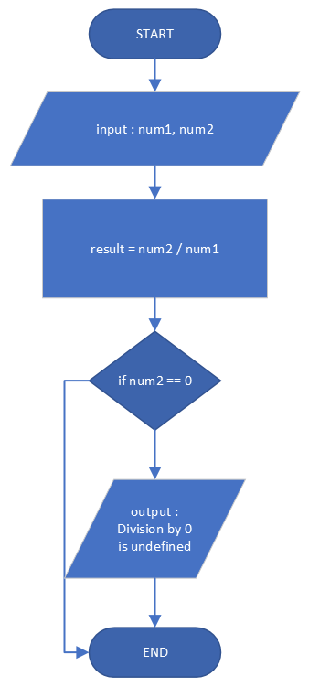

1. Write a program that prints the maximum number of four given integers. Use the cin

input operator to insert the four numbers entered by user and use the cout output operator

to display the maximum number.

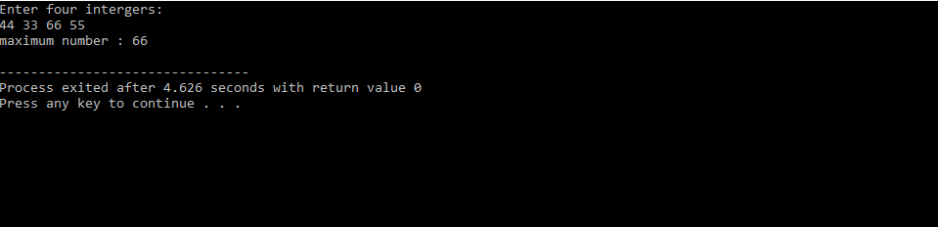

Output for question 2

1. Write a program that will tell the user if the number that he/she entered is even or odd. The program will exit if user enter 0. Use do. While loop.

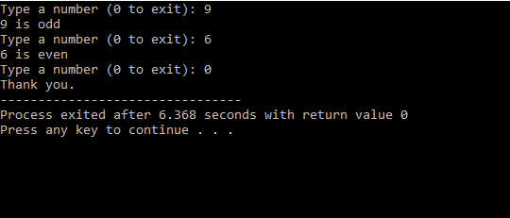

Output for question 3

1. Compile the program

|  |  |
| --- | --- |
| **INPUT (Enter Data)** | **OUTPUT** |
| 67 | The Sum of digits of 67 is 13 |
| 13 | The Sum of digits of 13 is 4 |
| 55 | The Sum of digits of 55 is 10 |
| 84 | The Sum of digits of 84 is 12 |
| 101 | The Sum of digits of 101 is 2 |
| 115 | The Sum of digits of 115 is 7 |